**Ideation Phase**

**Brainstorm & Idea Prioritization Template**

|  |  |
| --- | --- |
| Date | 19 Oct 2023 |
| Project Name | Data -Driven Insights on Olympic sports Participation and Performance. |

**Brainstorm & Idea Prioritization :**

**Step-1: Team Gathering, Collaboration and Select the Problem Statement**

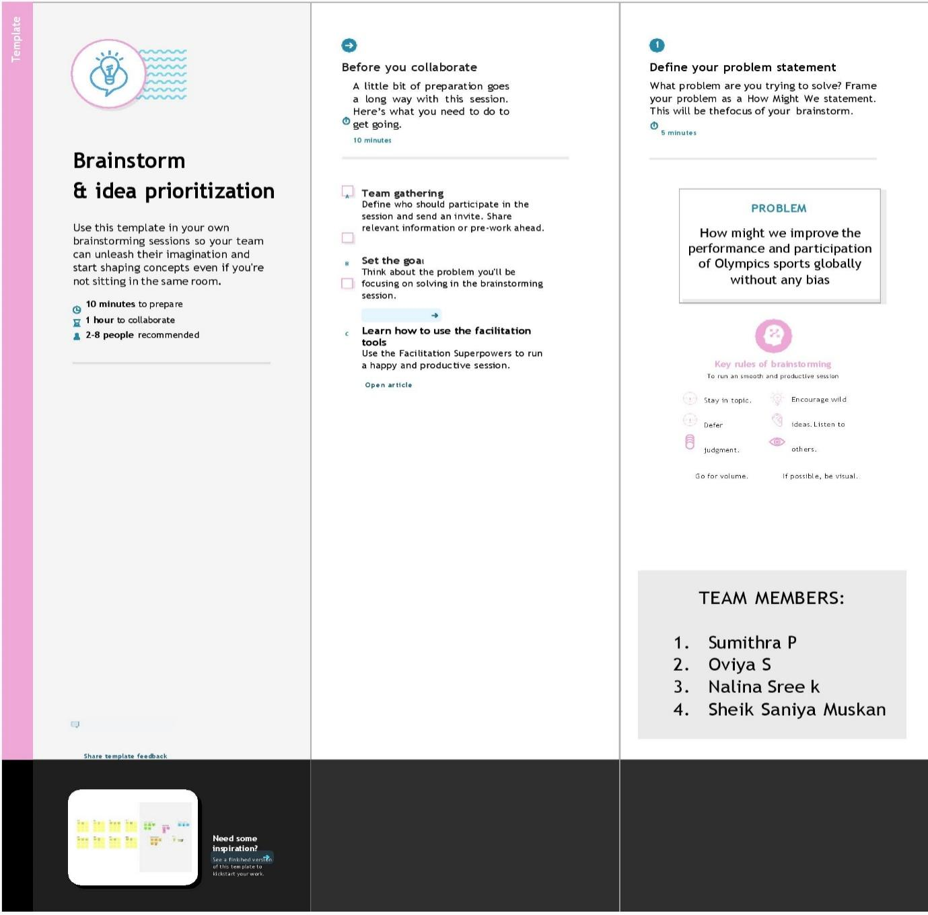

1.BALA S

2.KATHIRESAN S

3.SANTHOSH S

4.SURYA PRAKASH P

**Step-2: Brainstorm, Idea Listing and Grouping**

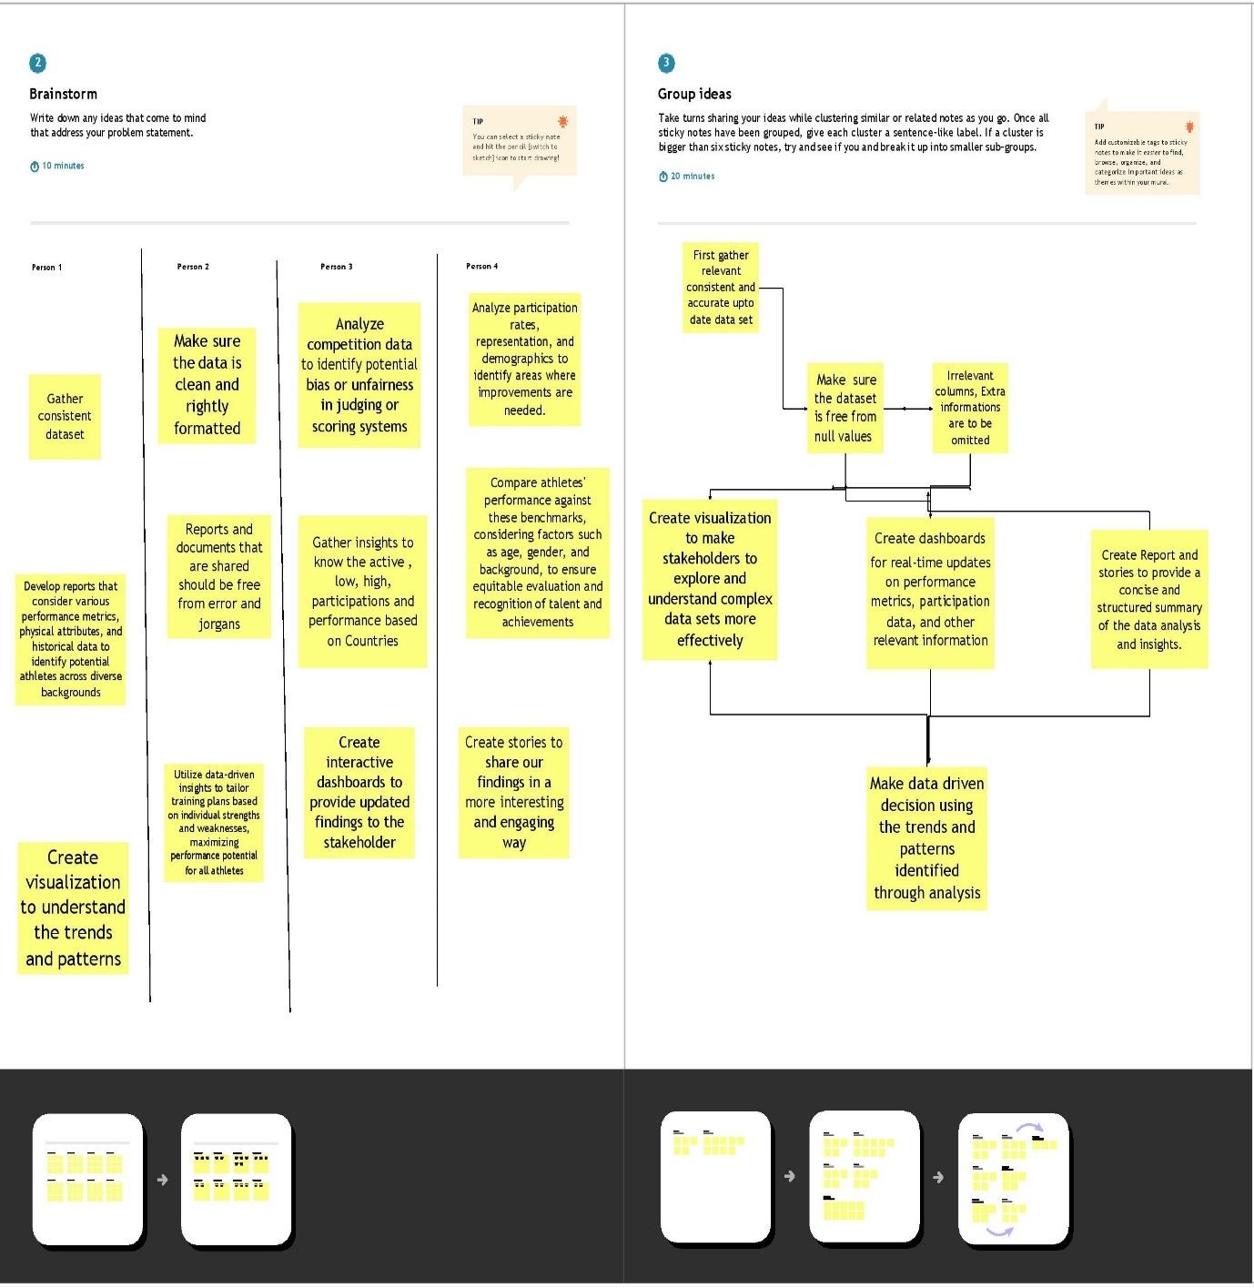

**Step-3: Idea Prioritization**

